OxBelt 2024 leg descriptions
Leg 1: Radley to Cumnor: 8.1 miles
https://www.strava.com/routes/3098211815350157796
Start: The Bowyer’s Arms pub, Radley Village
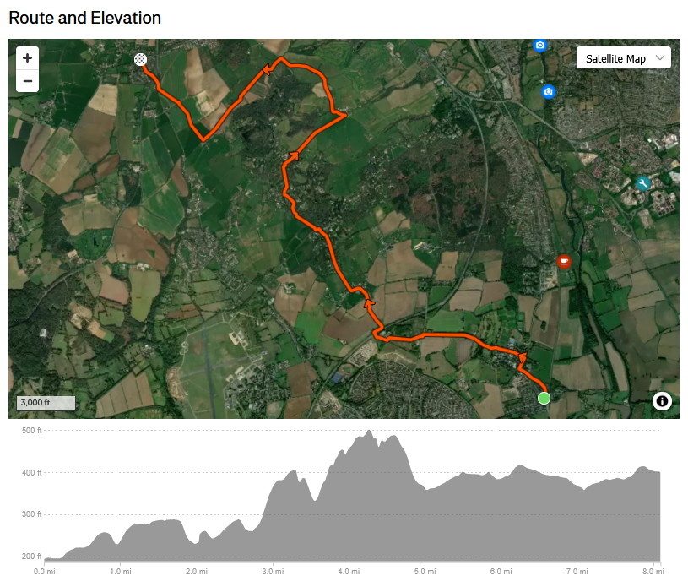
Run up through the village turning right onto Kennington Road then left up the main drive of Radley College. Go through the memorial arch and straight on with buildings on your left, heading W across the golf course. Keep going onto a footpath, cross Oxford Rd and continue W down lane then another footpath, and climb steps to cross A34 bridge, and on into Sunningwell. From Sunningwell Village Hall turn R to head NW through gates and climb up path between fenced fields. Follow Lincombe lane finding narrow footpath on L at junction which leads to Fox Lane (be careful, busy road and blind exit) and the Fox Inn. Pick up footpath on L side of the inn and head NW keeping woods on your R, then following the footpath into woods and climbing up into Old Boar’s Hill. Turn R though village then bear L to path heading N by Matthew Arnold’s field. Emerge onto Ridgeway then immediately turn R down narrow footpath heading NE, eventually descending steeply through field to Chilswell Lane. Turn L and follow lane for about half-mile until crossroads turning L and heading SW about same distance then turning R across fields at the first house you see. Follow edge of field then cross another field emerging up steps onto A420 slip-road (with care), turning R, crossing road and into Cumnor to checkpoint at Vine Inn.
Leg 2: Cumnor to Wolvercote: 8.9 miles
https://www.strava.com/routes/3098213453764215512
Start: The Vine Inn, Cumnor
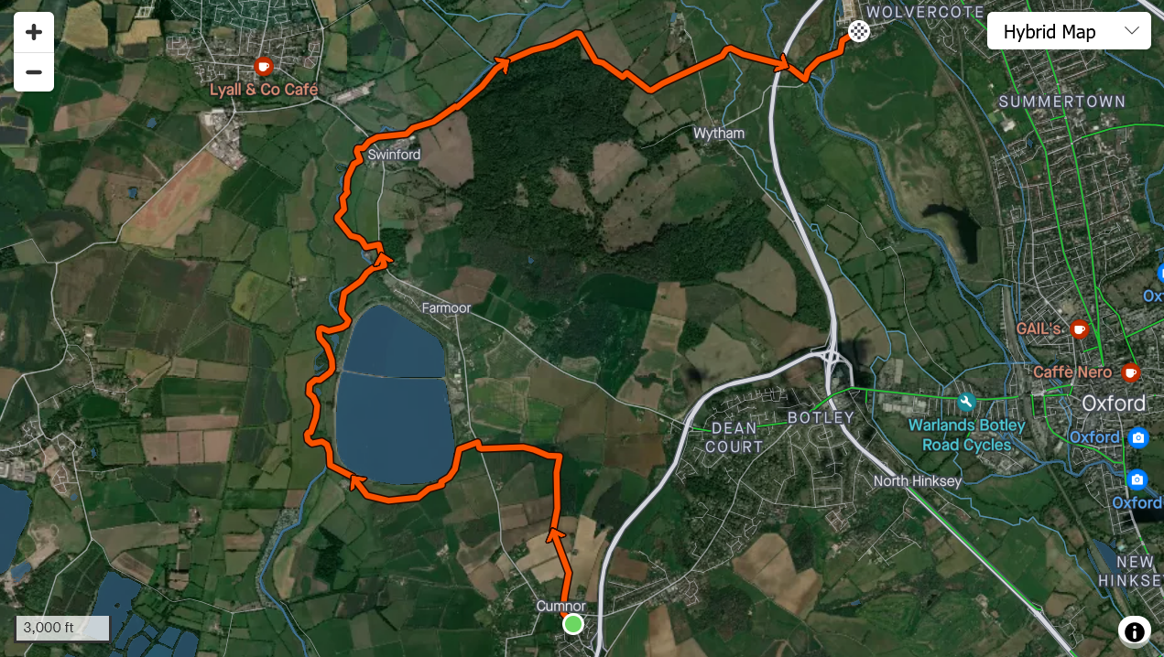
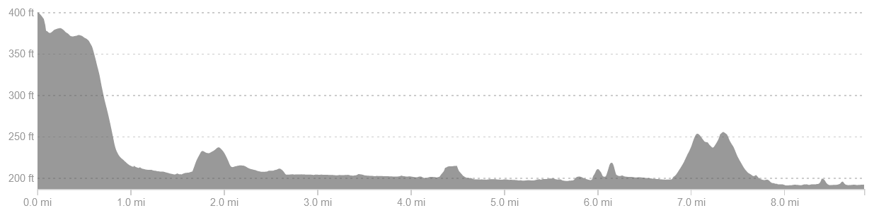
From the inn head N down lane and bear left across fields and downhill with woods on R and view to reservoir. At bottom of hill cut through hedges turning L and then diagonal across fields to Cumnor road. Take Lower Whitley Road to footpath and lane round S of reservoir. At farmhouse follow footpath joining Thames and follow river path until you reach the B4044 main road. Turn L then L down into boatyard rejoining Thames path across fields and past moorings, under Swinford toll bridge, and on past the Lock (there is drinking water here if needed, round the far side of the sanitary station). Keep following through Wytham woods and upon emerging into field follow edge of woods round to R before turning R through gate and SE up driveway, through two fields then L to descend NE, across lane and up driveway opposite. Footpath cuts R across fields to river, under A34 and to Godstow. Turn L along road, crossing the bridge then following the road round to the left then right to the checkpoint at the village green.

Leg 3: Wolvercote to Kidlington: 8.4 miles
https://www.strava.com/routes/3098216423844369892
Start: Wolvercote village green
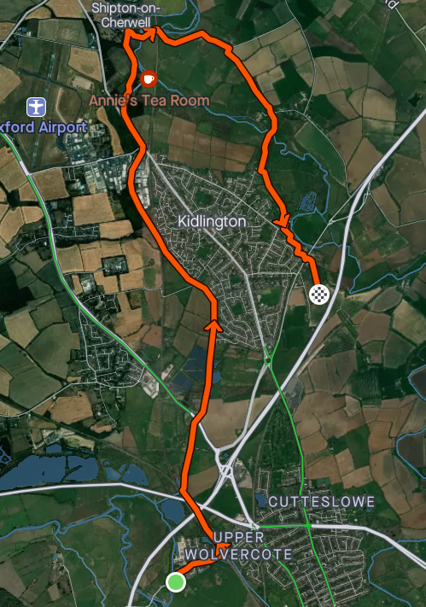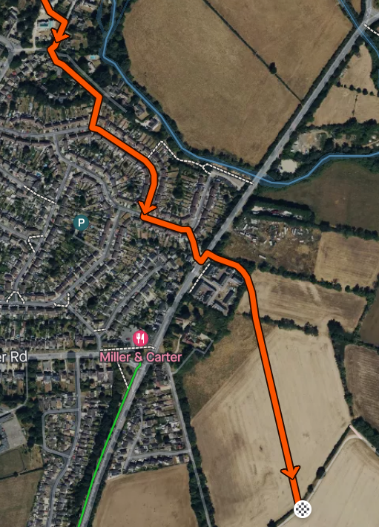
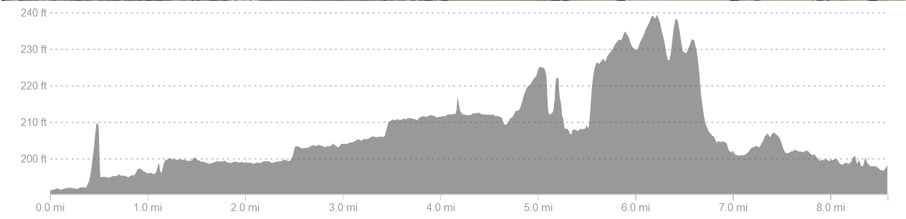

Go through Wolvercote taking Godstow Road E and turn N up canal immediately after rail bridge. Follow all the way to Thrupp (water here at Annie’s Tea Room by bridge if needed) crossing bridge and continuing N up RH bank of river to Shipton-on-Cherwell. Turn R and leave river, crossing field and going under rail bridge following path to Hampton Gay Farm, then the lane for about ¼ mile before turning sharp R across narrow field then L to follow path SE until it reached the church at Hampton Poyle. Cross another field, cross footbridge and follow footpath S to St Mary’s Church in Kidlington. Follow footpath opposite church S for 0.6 miles then turn R out onto Mill Street and at the next junction take Woodlands then another footpath to L of a house. Emerge shortly to follow Watermead, Cherwell Ave and Queen’s Ave before cutting through a footpath on the R and crossing the Bicester road. Take footpath by bus stop which goes SE across fields to the checkpoint.

Leg 4: Kidlington to Beckley: 7.6 miles
https://www.strava.com/routes/3098218051701645138
Start: Farm track off Water Eaton Lane, Gosford
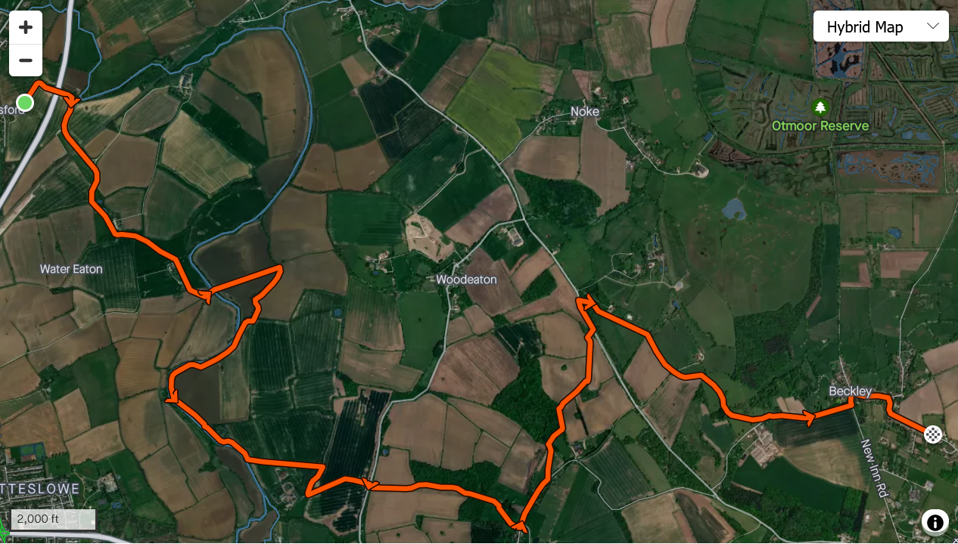
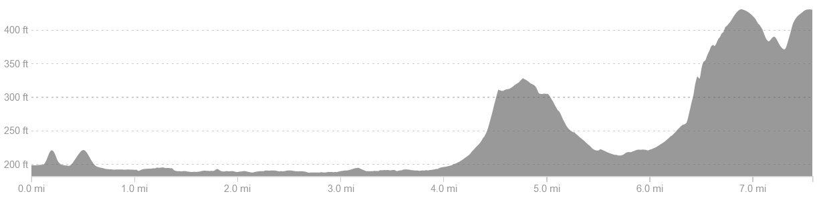
Head E, crossing A34 bridge then rail bridge, go past a farm, then at sharp RH bend follow footpath straight on round back of Water Eaton Manor. Cross field and then foot bridge across Cherwell river then straight across another large field, and through hedges. Turn R and follow path back to the river then follow for 1 mile, taking footbridge to pass through a copse, then cut L across a field towards Sescut Farm shortly after emerging. Keep to L of the trees to go round N edge of farm buildings then cut R and L to head up the driveway to the Woodeaton Road. Cross and head up the hill to Elsfield, turning L onto road for ~400m and then L through hedge following footpath N downhill to Woodeaton Wood. At top of wood bear R for ~100m then turn L down through wood. Turn R out into field and bear left before cutting R into adjoining field and turning L to head down to the B4027. Turn L along the road for ~300m then take sharp R up lane and footpath heading SE up gentle incline. After 0.8 miles turn R off footpath uphill through field to copse and through a second field to Common Road, turning L then L down into Beckley following road round to R, past the Abingdon Arms pub, R up the hill bearing L along Woodperry Road. The checkpoint is at the community centre about 400yd along on the L.

Leg 5: Beckley to Shotover Plain: 5.0 miles
https://www.strava.com/routes/3098220294466526692
Start: Beckley Village Hall, Woodperry Road
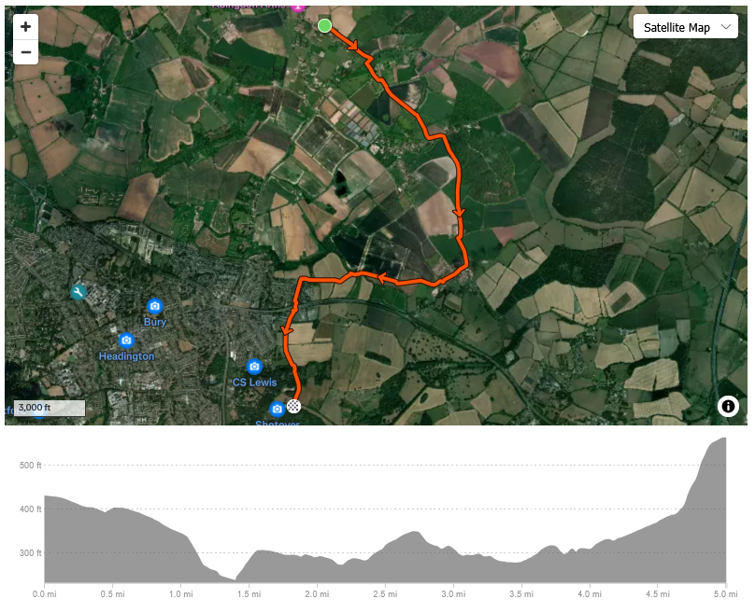
Carry on SE along Woodperry Road, and at the end turn R then L immediately through Woodperry House grounds, leaving via SE heading along track beside fields. After half a mile find gate and head diagonally R downhill and through copse then take R edge of field to Mill St. Turn L and then after 200m turn R through a gate and up the hill, keeping wood on L until farm track. Turn right onto the track to go through the farmyard and into field opposite. Follow R edge then turn R through paddock and R onto lane up into Forest Hill. Cross over to Main St and straight on turning R at village hall then L once on common. Follow footpath W across fields, crossing Bayswater Brook at ‘troll bridge’ and then W again up into Sandhills taking first L to the P&R. Take underpass and footpath opposite up to playing fields and keep left up to a small bridge and footpath climbing steeply to the checkpoint on Shotover Plain.

Leg 6: Shotover Plain to Toot Baldon: 4.8 miles.
https://www.strava.com/routes/3098207065033462244
Start: Shotover Plain
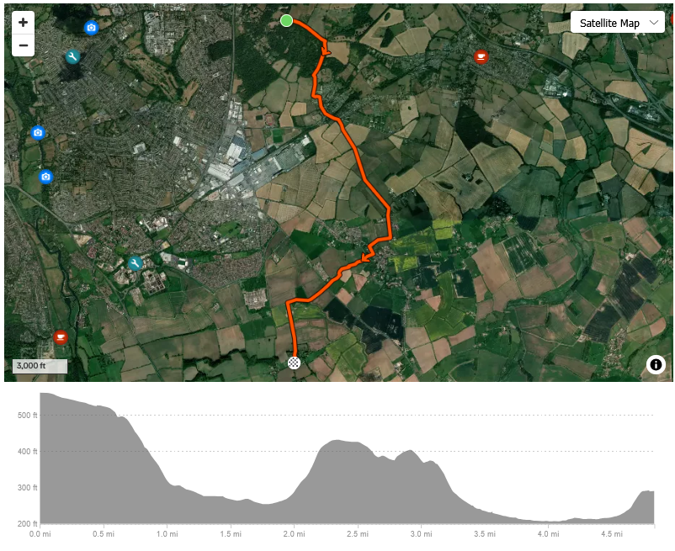
Head E along Old Road, and at the end of the plain pass through hedge into field and turn R round the back of Shotover woods then down through woods on footpath and sharp left at waymarker, exiting woods and descending further through two fields to kissing gate just past the farmyard. Take the footpath into Horspath then turn R at Oxford brewery, down through village then under old railway bridge and bear right through farm gate and across fields, in 4th field heading up hill under the pylon, then footpath to Garsington. Turn R on Wheatley Road and follow until pavement ends then footpath R up and over ridge with great views at top. Descend L to road, turn L for ~100 yards then sharp R through kissing gate to another footpath, and descend again through a field heading SW out of Garsington. After a couple of fields keeping SW bearing, find driveway with swing gate at end, cross B480 to footpath opposite. Follow LH edge of field then bear diagonally R across second field towards a copse and take short woodland path before a L turn towards Toot Baldon. Watch out for the steep climb in the last 200m!

Leg 7: Toot Baldon to Abingdon Lock: 7.4 miles.
https://www.strava.com/routes/3098208606704336600
Start: The Mole Inn, Toot Baldon.
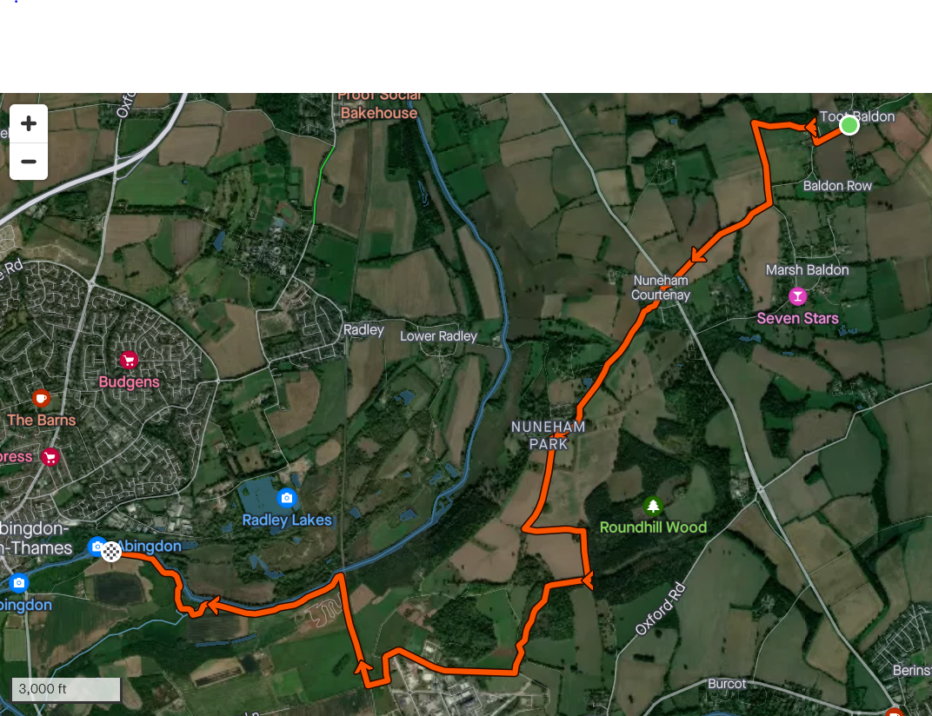
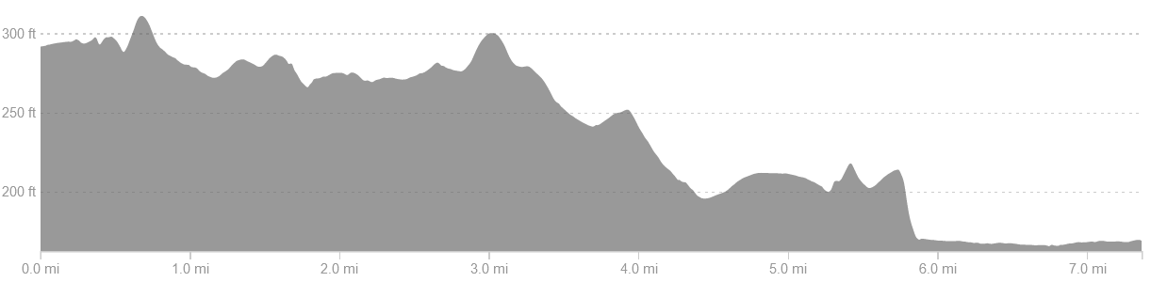
Head SW down lane then R onto track. Follow track round to L through woods then cross stile and turn L again heading S along edge of field back to road. Take bridleway on R to Nuneham Courtenay and cross A4074 (carefully!), through gardens and towards NC Estate. Keep L through estate (heading S) then sharp L by a house and R onto a footpath immediately after another house. Enter woods and turn R, following muddy path W then S, emerging at Culham Science Centre. Turn R and go half way round perimeter road anticlockwise, then turn R to cross rail bridge. Once over the bridge, turn R immediately to pass through the gate and up the trail running parallel with the railway. Descend to the river and follow the bank W, cutting through a copse and crossing a field to rejoin the river and finish at the lock.

Leg 8: Abingdon Lock to Radley: 4.3 miles.
https://www.strava.com/routes/3098210533860142930
Start: Abingdon Lock, south side.
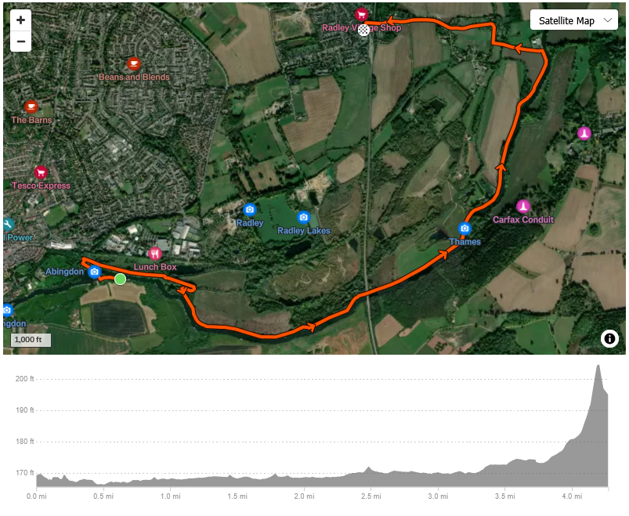
Cross the lock and turn R over rainbow bridge then R again to pick up the Thames Path. Keep going along the path to Radley College Boathouse. Turn L up the driveway then R at the top, following road round to L towards village and up over railway bridge. Turn L and finish at Bowyers Arms pub.

